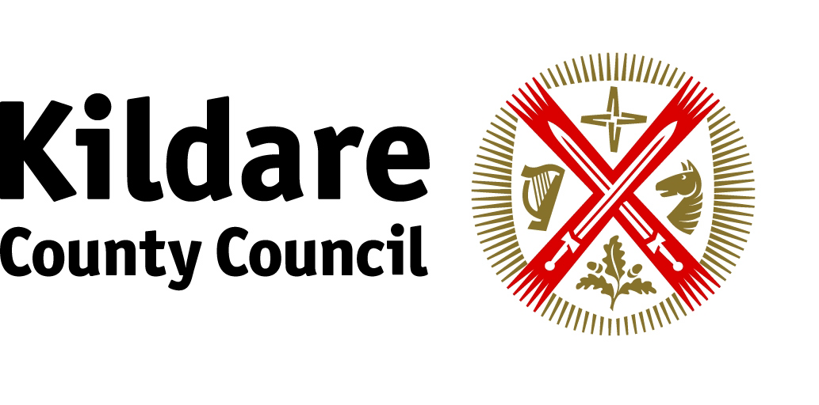

Kildare County Council Arts Service

ARTISTS MENTORING PROGRAMME

APPLICATION FORM

NAME: ………………………………………………….…………

ADDRESS:……………….………………………………………

…………………………………………………………………………………………

…………………………………………………………………………………………

TEL……..………………………… EMAIL………………………………………….

ARTFORM
Visual Arts □ Drama □ Music □ Photography □
Other □ Please describe……………………………………….

Please outline the reasons why you wish to apply for the Mentoring Programme and how you feel that you would benefit as a result of participating on the programme.

…………………………………………………………………………………………..

……………………………………………………………………………….………….

…………………………………………………………………………………………..

…………………………………………………………………………………….…….

…………………………………………………………………………………….…….

…………………………………………………………………………………………..

……………………………………………………………………………….………….

…………………………………………………………………………………………..

…………………………………………………………………………………….…….

…………………………………………………………………………………….…….

All applications must be accompanied by a CV, outlining details of experience to date. Applicants may also provide links to websites and online examples of work.

Please return completed applications to: Nicola Dunne, c/o Kildare County Council Arts Service, Main Street, Newbridge, Co. Kildare
CLOSING DATE: Wednesday 8 February 2012

